ASSIGNMENT-04

**Q1** Given a linked list of n nodes and an integer k, write a function to rotate the

linked list counter clockwise by k nodes.

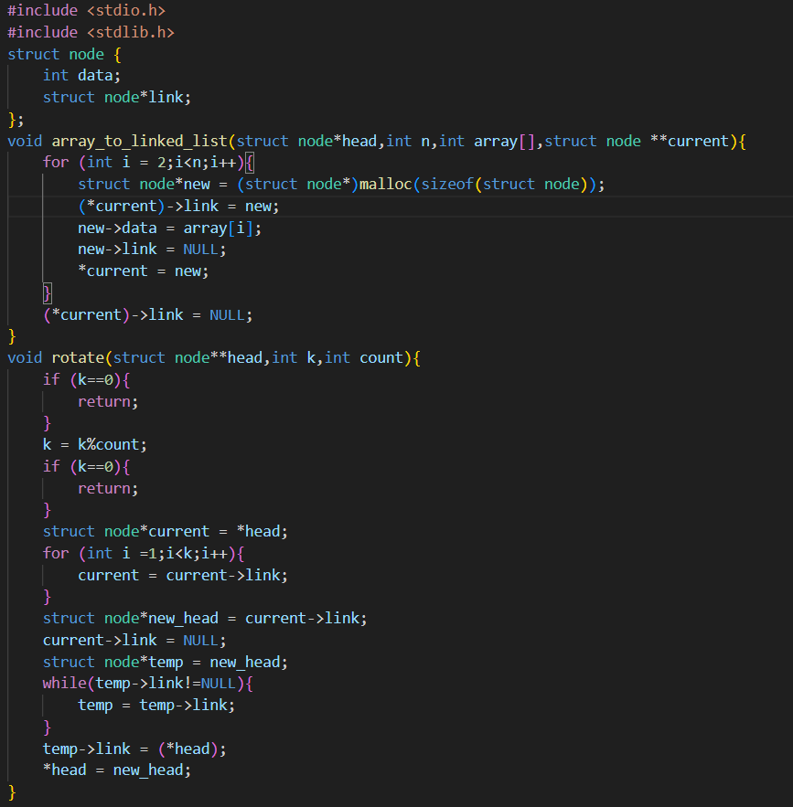

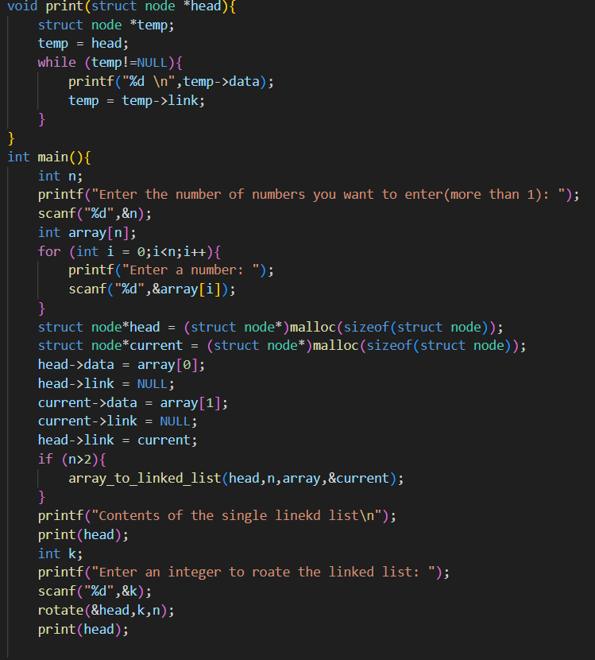

**OUTPUT:**

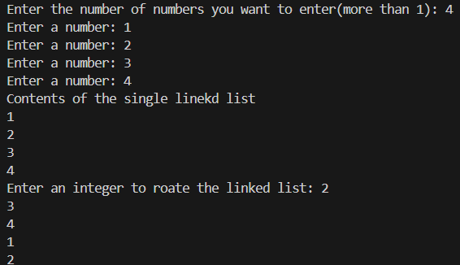

Q2 Given an unsorted linked list of n nodes, remove duplicates from the list.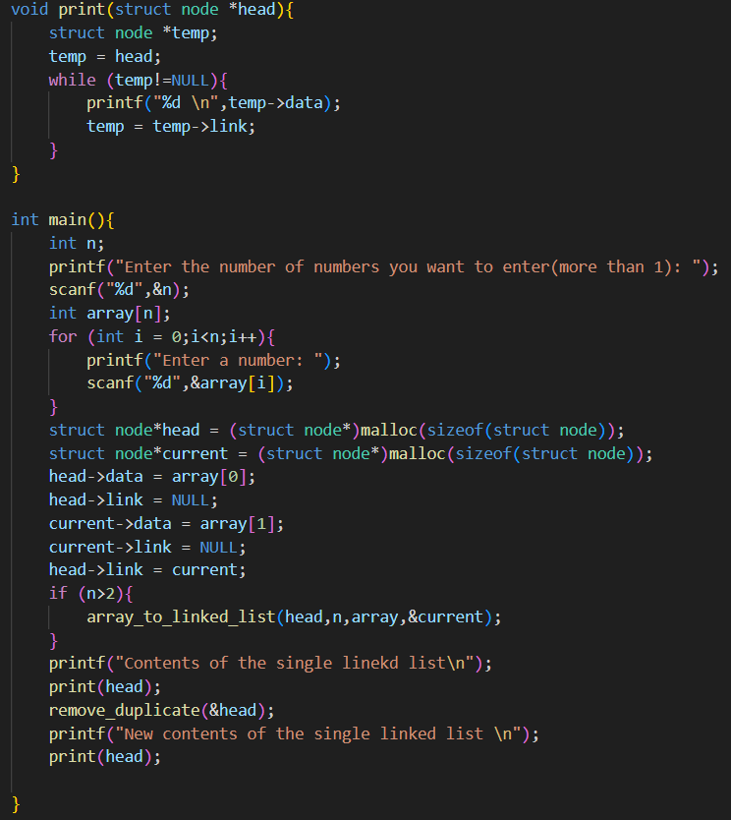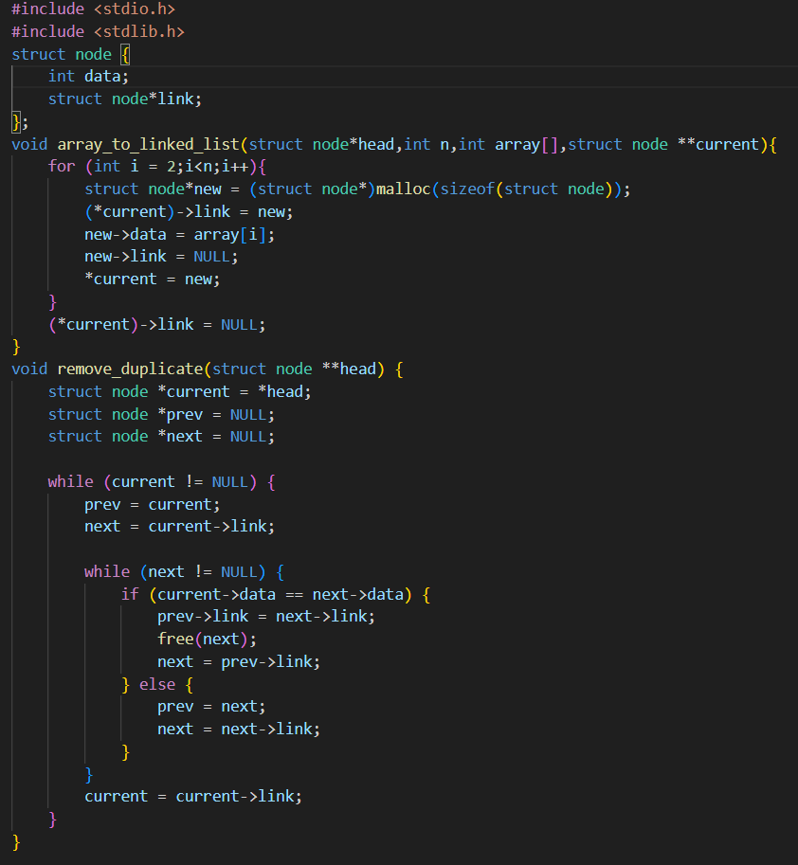

**OUTPUT:**

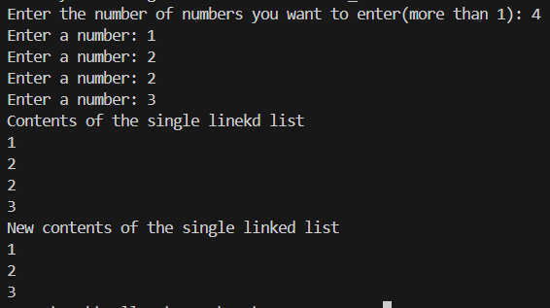

Q3 Detect if the single linked list contains a loop or not.

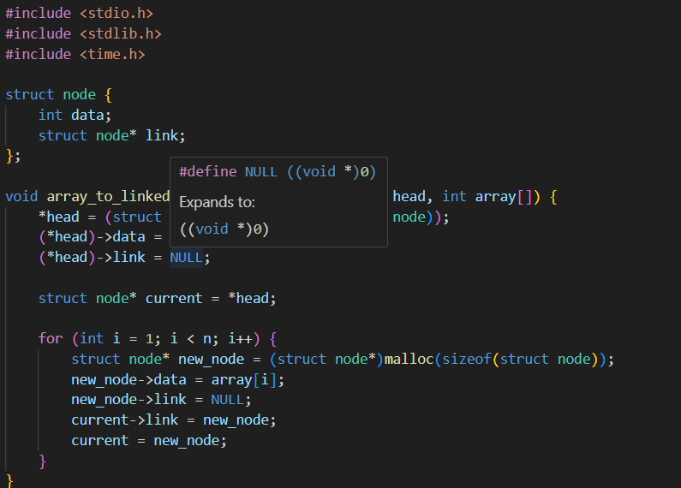

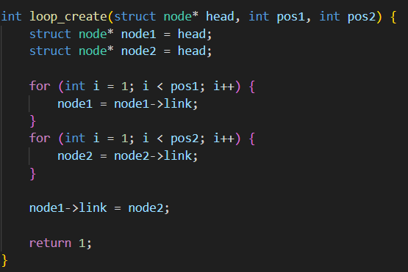

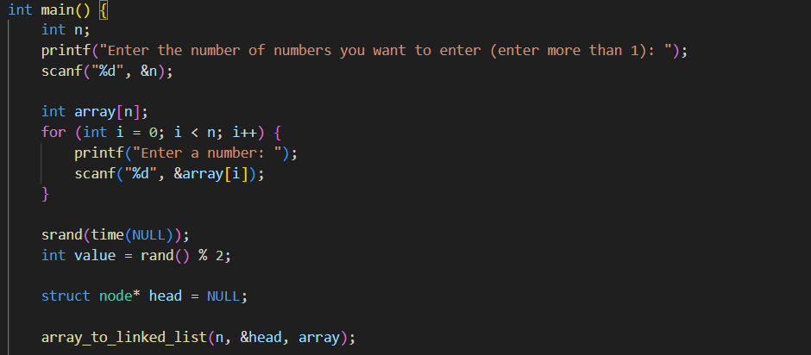

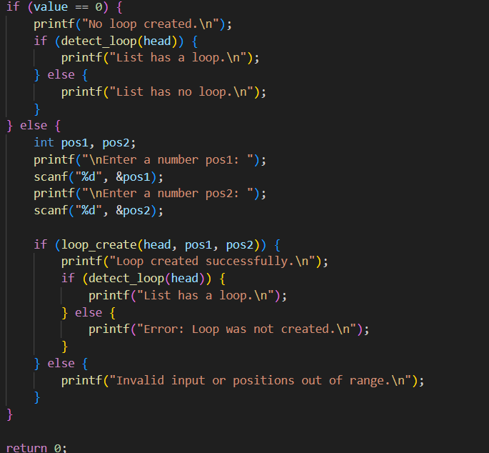

OUTPUT:

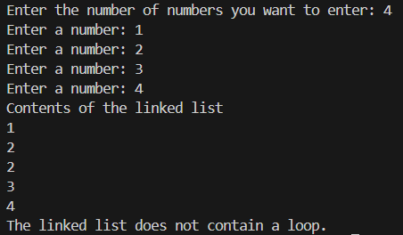

Q4Q4: Write a C/C++ program to implement doubly linked list with the following function (i) insertAtFirst(&head, new_data): This function should insert the new data/element at the beginning of the linked list. (ii) insertAtEnd(&head, new_data): This function should insert the new data/element at the end of the linked list (iii) insertAtMiddle(&head, new_data): This function should insert the new data/element at the middle of the linked list (iv) insertAfterNode(&head, given_node, new_data): This function should insert the new data/element after the given node in the linked list.

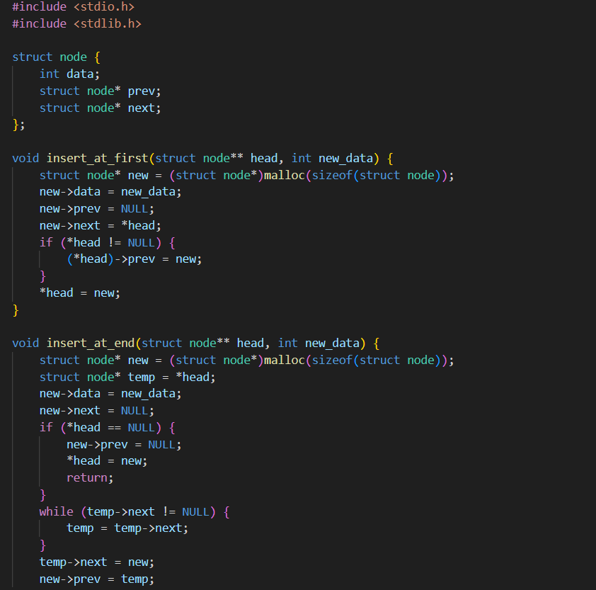

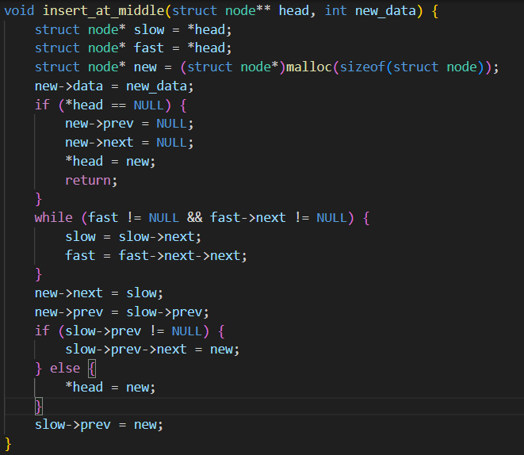

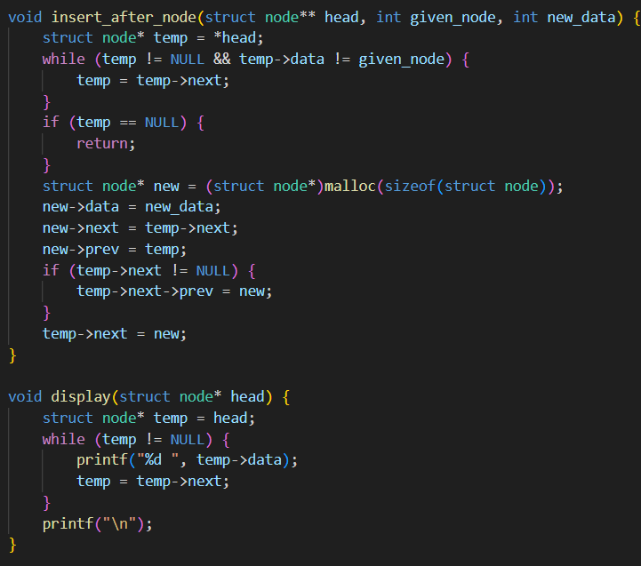

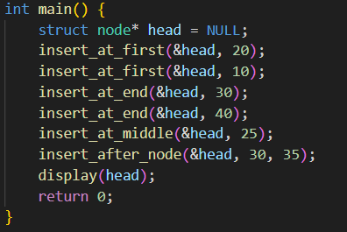

OUTPUT:

